EXPERIMENT NO. 17
DESIGN AND IMPLEMENTATION OF IMAGE WATERMARKING USING OPENCV
PROGRAM:
import cv2

# Read the original image
img = cv2.imread("sobel_input.png")

if img is None:
print("Image not found! Check the filename.")
else:
# Add a visible text watermark
cv2.putText(
img,
"HARINI",
(50, 100),
cv2.FONT_HERSHEY_SIMPLEX,
2,
(0, 0, 255),
5,
cv2.LINE_AA
)

# Display the watermarked image
cv2.imshow("Watermarked Image", img)

# Save the output image
cv2.imwrite("watermarked_image.png", img)

print("Watermark added successfully!")

# Wait for a key press and close the window
cv2.waitKey(0)
cv2.destroyAllWindows()
COMMANDS USED:
cd Desktop
cd opencv
python experiment17_watermark.py

OUTPUT:
The original image was displayed with the text watermark "HARINI" in red at the top-left corner. The watermarked image was saved as watermarked_image.png in the opencv folder.
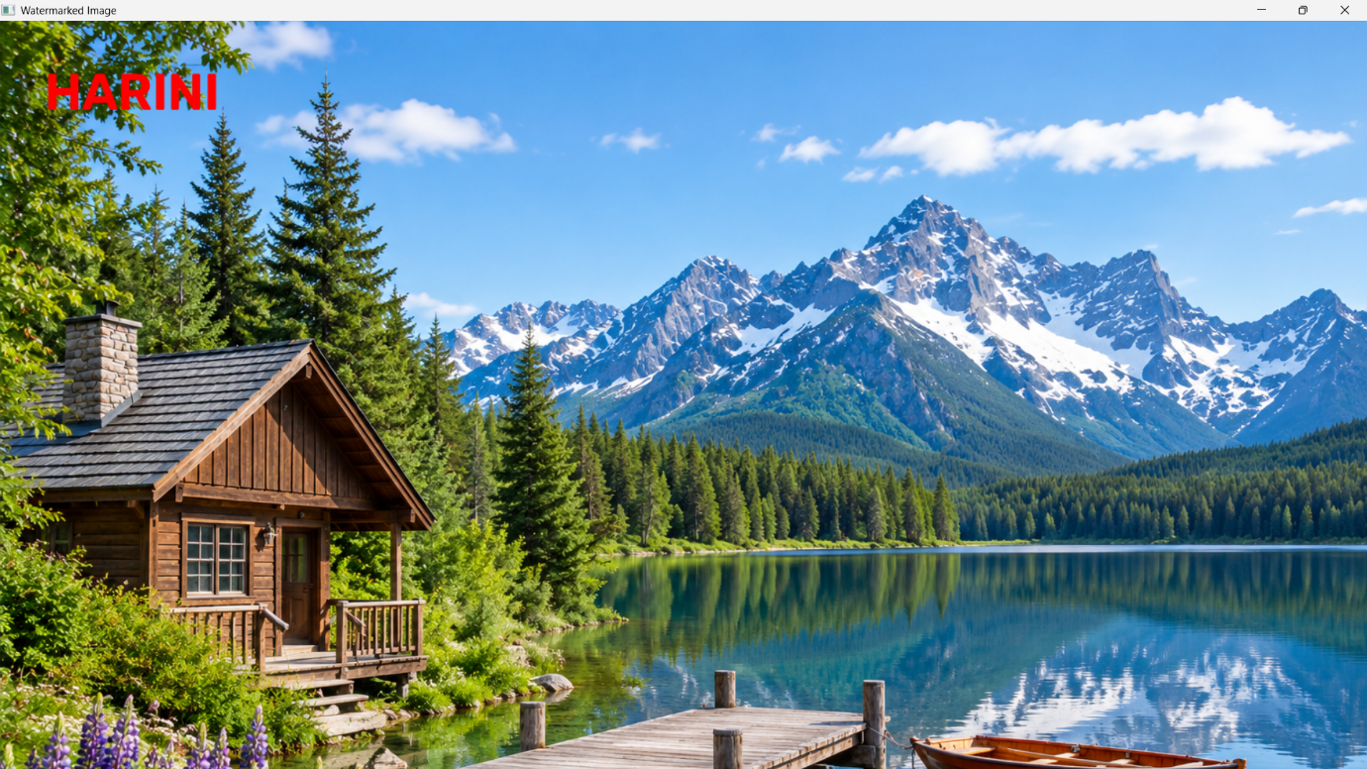

RESULT:
The image watermarking program was successfully executed using OpenCV, and the watermarked output image was generated and saved.

